11. React-JS HOL

Name:- Shubham Sangram Bej

Hands-on 11

Objective
- Understand React Event Handling.
- Invoke multiple methods using a single button click.
- Pass arguments to event handler methods.
- Handle Synthetic Events in React.
- Create a Currency Convertor component using event handling.

Software Requirements
- Node.js
- npm
- React
- Visual Studio Code

Project Name
eventexamplesapp

Procedure
- Created a new React application named eventexamplesapp.
- Created the CurrencyConvertor component inside the Components folder.
- Implemented a counter using React state.
- Added an Increment button that:
  - Increments the counter.
  - Invokes the SayHello() method.
- Added a Decrement button to decrease the counter.
- Added a Say Welcome button to demonstrate passing arguments to an event handler.
- Added a Click on me button to demonstrate React Synthetic Events.
- Implemented the CurrencyConvertor component using two input fields:
  - Amount
  - Currency
- Performed currency conversion when the Submit button was clicked.
- Executed the application using:
npm start
- Verified the output in the browser.

Output
The application successfully demonstrates React event handling, multiple event invocation, passing arguments to event handlers, synthetic events, and a simple currency conversion example.
(1st Increment (from 0 – 1))
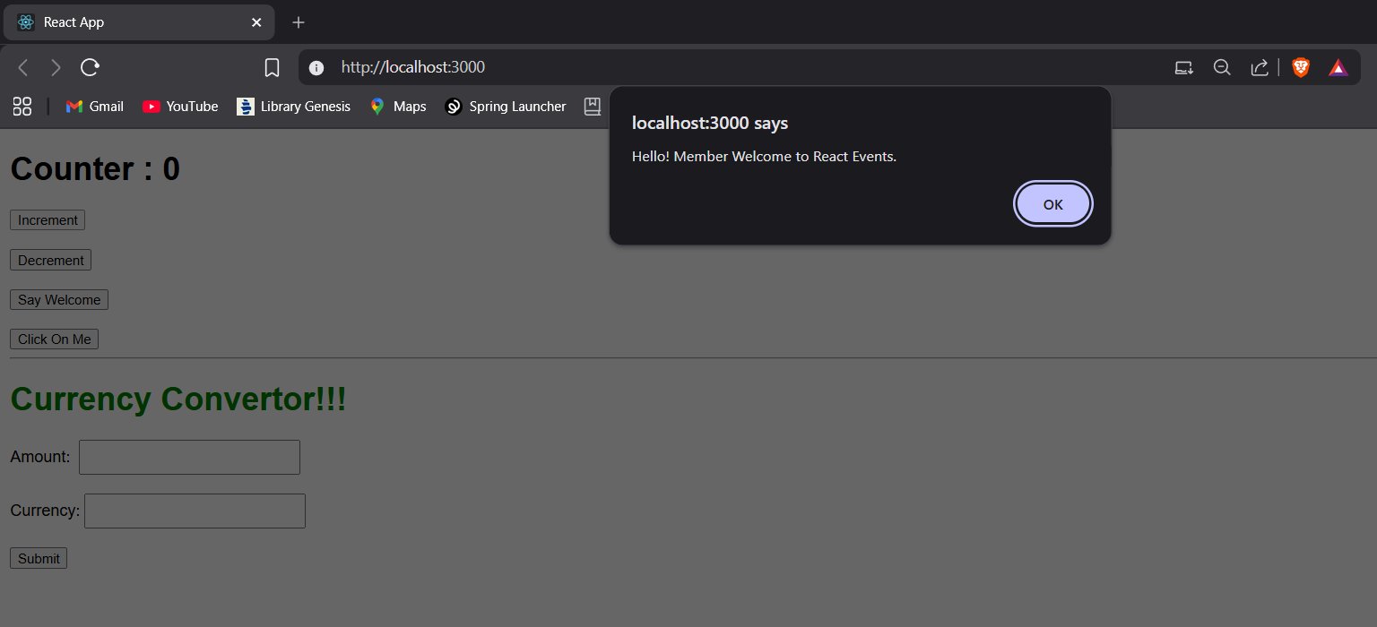

(2nd Increment (from 1 – 2))
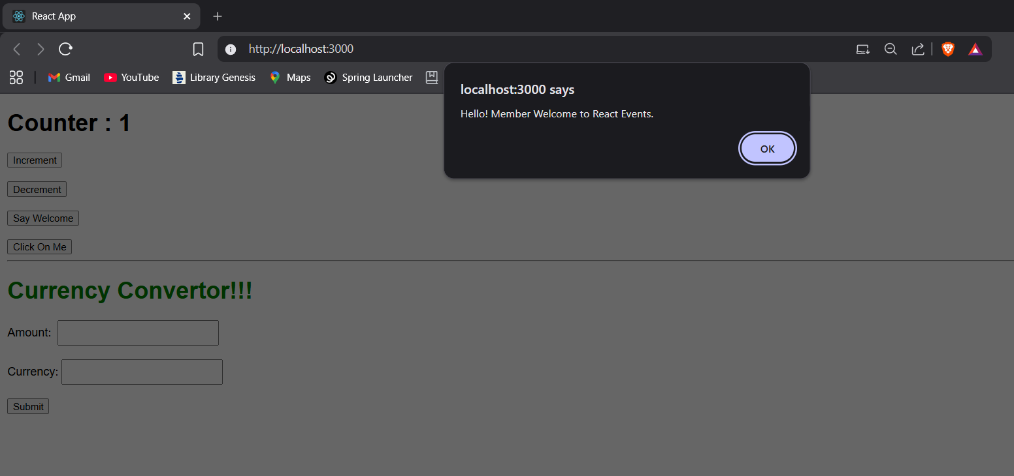
(Decrementing)

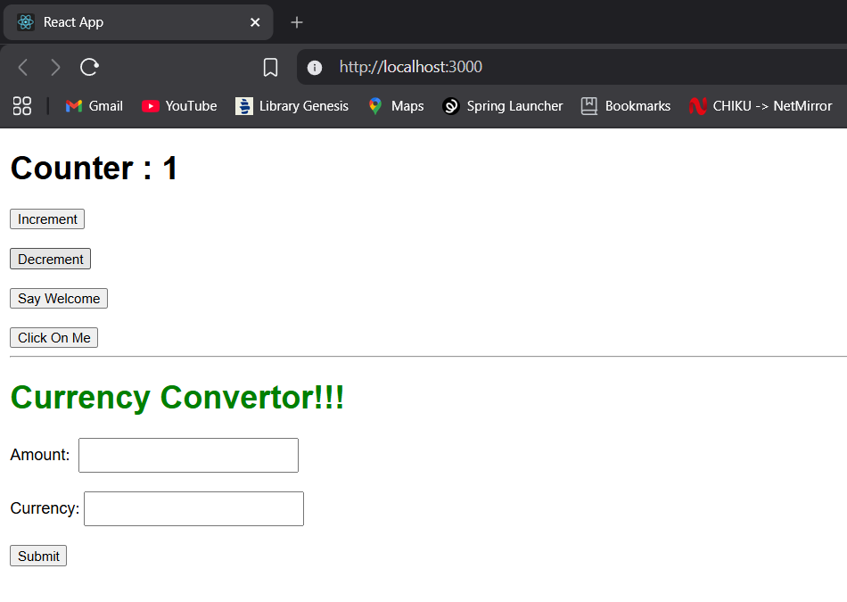

(On clicking the Say Welcome Button)

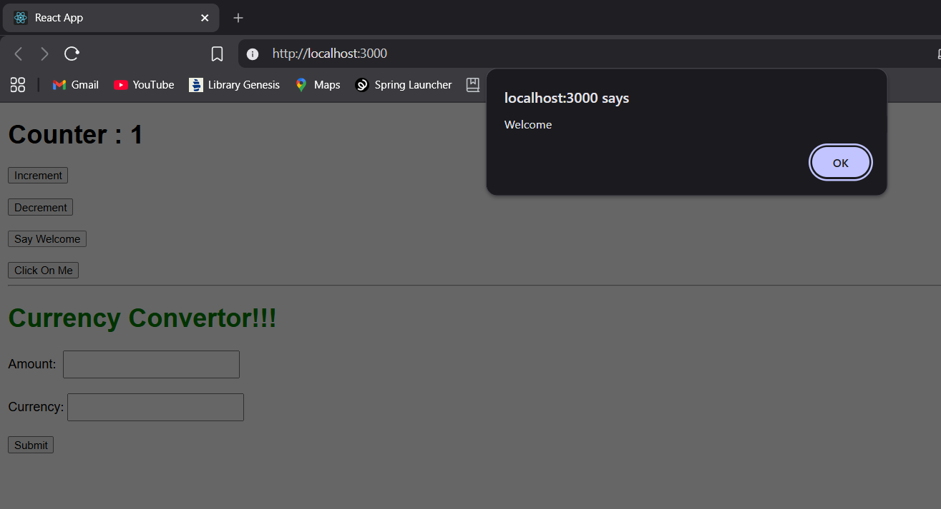

(On clicking the Click On Me Button)

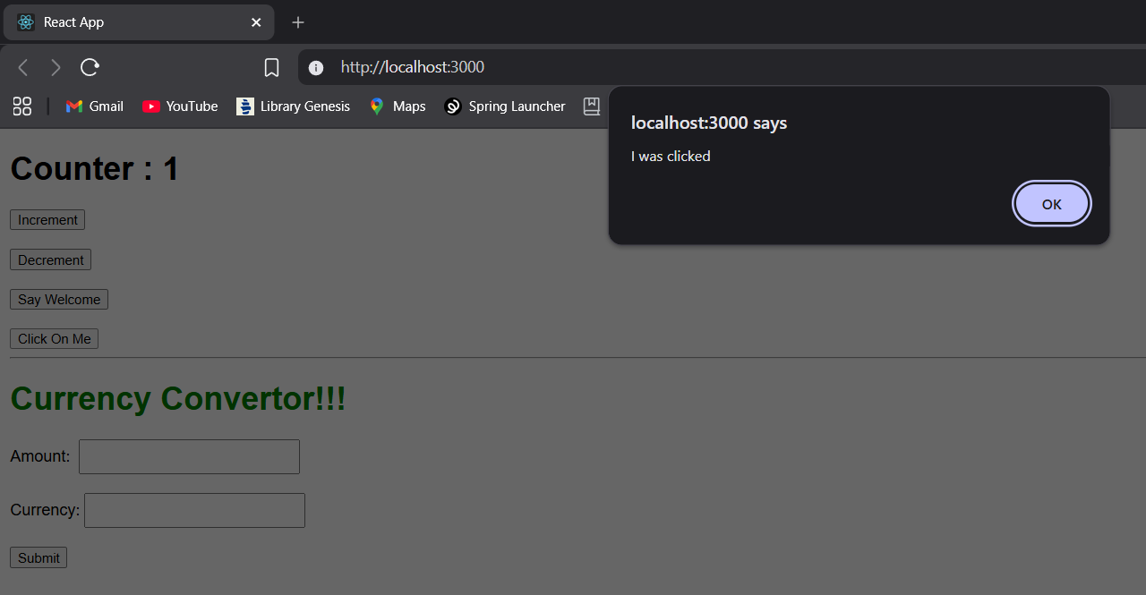

(Currency Convertor Working)

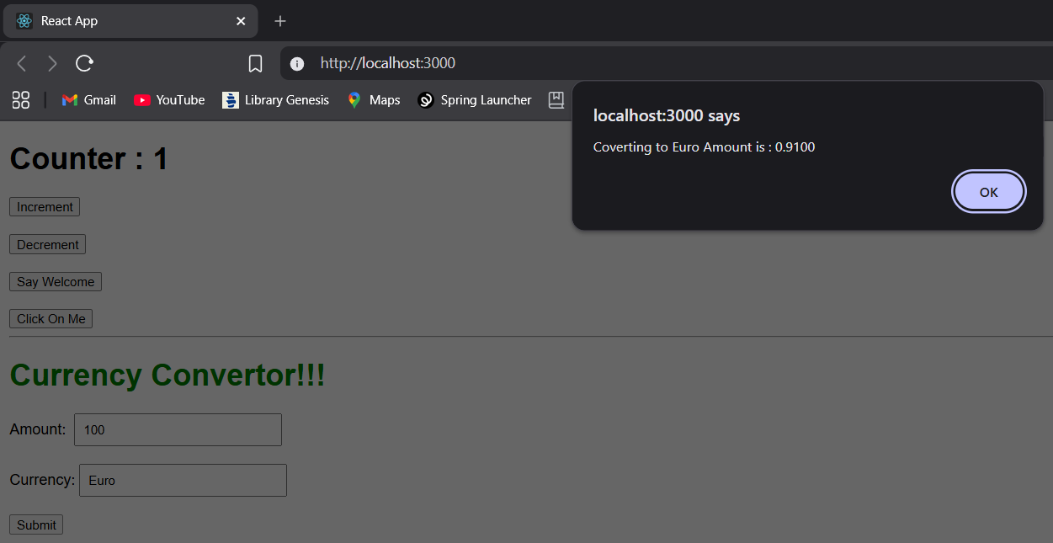

Result
The React application eventexamplesapp was successfully developed and demonstrates different types of event handling techniques in React.

